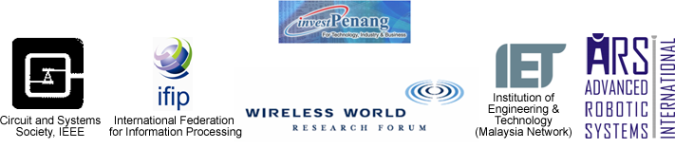

CONFERENCE REGISTRATION FORM

Submit your full paper either by post or via E-mail together with this form. Please include a copy of diskette if sent by post. This form is also available at http://ee. eng.usm.my/ rovisp07

- Paper presented ( paper no. )

a. | b. | c.

2. Fill in your name and state whether you are a presenter, attendee, member or non-member of IEEE

First Name |  |  |  | Middle name |  |  |  |  |  |  |  | Family name
Title
Prof Dr Mr Ms Please check one box only
Company/Organization

Mailing Address

City |  | Post code/ZIP code |  |  |  |  |  | State |  |  |  |  |  |  | Country
Phone (Please include country code) |  |  |  |  |  |  |  | Fax (Please include country code)
E-mail |  |  |  |  | Presenter |  |  |  | Attendee |  |  |  | Member of IEEE |  |  |  | Non-member of IEEE
IEEE membership no.

3. Dietary (please tick): | Vegetarian |  |  |  | Non-vegetarian
4. Payment
 | Member of IEEE (US$200/RM700) | Others  (US$230/RM800) | Students  (USD140/RM500)
Registration fee

By (please tick)
 |  | Cheque |  |  |  |  |  |  |  |  | Bank Draft |  |  |  |  |  |  |  |  |  |  |  |  |  | Cash (in RM)
Cheque or Bank
draft no.
Cheques and Bank drafts must be made payable to " Bendahari Universiti Sains Malaysia" and sent to:
Organizing Secretary, International Conference ROVISP 2007, School of Electrical and Electronic Engineering, Engineering Campus, Universiti Sains Malaysia, 14300 Nibong Tebal, Seberang Perai Selatan, MALAYSIA.
Tel.: +604-5995999 ext 6001 Fax.: +604-5941023 E-mail: rovisp07@eng.usm.my

